**INDIAN INSTITUTE OF TECHNOLOGY, KANPUR**



**SURGE 2022**

*Project Report*

**“Visualisation of flow past various bluff bodies/filament configuration in a flowing soap film”**

Submitted by

**Vikas Varshney**

SURGE No.: 2230518

Department of Civil Engineering

IIT KANPUR (U.P.)

Under the Guidance of

**Dr. SACHIN Y. SHINDE**

Department of Mechanical Engineering

IIT KANPUR(U.P.)

**CERTIFICATE**

This is to certify that the project entitled **“****Visualisation of flow past various bluff bodies/filament configuration in a flowing soap film”** submitted by **Vikas Varshney** (201118) as a part of Summer Undergraduate Research and Graduate Excellence (SURGE) Program 2022 offered by Indian Institute of Technology, Kanpur, is a Bonafede record of work done by him under my guidance and supervision at Indian Institute of Technology, Kanpur from 13th May, 2022 to 14th July, 2022.

**Dr. Sachin Y. Shinde**

Assistant Professor

Department of Mechanical Engineering

Indian Institute of Technology, Kanpur

**ACKNOWLEDGEMENT**

*“It is not possible to do research experiments without the assistance and encouragement of other people. This one is certainly no exception.”*

On the very outset of this report, I would like to express my deep gratitude to **Dr. Sachin Y. Shinde** for giving me such an opportunity to work under his supervision. I am thankful to Sir for guiding and mentoring my research project. His motivation gave me a chance to explore my caliber.

I would also like to thank **Mr. Chandan Pothal** (MS Student) and **Mr. Sarthak Patel** (MTech Student) for their advice and assistance in keeping my progress on schedule. They helped me in understanding the concepts and theoretical aspects related to this research experiment. They were always with me whenever I was stuck.

I would also like to extend my gratitude to **Indian Institute of Technology, Kanpur** for giving me this wonderful opportunity in which I learned a lot about Soap Film Tunnel.

Finally, I wish to thank my parents for their support and encouragement throughout my study.

Thanking You

**VIKAS VARSHNEY**

**ABSTRACT**

Formation of infamous von-Kármán vortex streets by circular rods is studied in a flowing soap film tunnel. The two-dimensional fluid flow in the film allows stable vortex streets to be generated and studied over a broad range of flow rates, 10 ml/min to 50 ml/min. There have been many studies of the Kármán vortex streets. The current study focuses on the universal feature of the near-wake structures generated by circular cylinders in a uniform two-dimensional (2D) flow. This work includes Observation of von-Karman vortex street in the wake of a circular cylinder (6mm diameter) in a flowing soap film at various flow rates, Visualisation of wake behind the square cylinder with an attached filament (a human hair, a thread) in a flowing soap film. All these flow patterns are analysed by using the concept of object identification and image tracking in Python-OpenCV library. This helps in calculating shedding frequency of vortices in flowing soap film. This report also includes the observation of fish schooling by visualizing vortex generation due to four flexible filaments rigidly mounted at leading edge in a diamond configuration.

**Contents**

**Page No.**

Certificate 2

Acknowledgement 3

Abstract 4

1. Introduction 6
2. Background 7
3. Experimental Setup 8
4. Visualisation 10
   1. Using Circular Cylinder
   2. Using Square Cylinder
   3. Using Four filaments in Diamond Configuration
5. Vortex Detection 12
6. Conclusion 15
7. References 16
8. **I****NTRODUCTION**

The analysis of the wake structure formed behind objects with different shapes, such as the recirculation region (wake bubble) and the vortex street formation shed at the trailing edge of a body—is a classical problem in fluid mechanics. Although many advanced experimental flow visualization and flow measurement, such as particle image velocimetry or laser Doppler velocimetry, have been developed and used in fluid dynamics research, the use of flowing soap films has remained as an educational tool and economical visualization technique to study fluid-structure interaction and hydrodynamic instability in two-dimensional fluid flows. Making use of the optical properties of the soap film and high-speed photography, the wake evolution and vortex patterns behind different bodies can be tracked and captured.

Liquid films, usually called Soap films, are made up of surfactant solutions. A Surfactant is not necessarily a soap, are very thin, self-sustained fluid layers in which hydrodynamical experiments can be done.

Liquid(soap) films can be visualized through light interference effects produced by small variations in the film thickness. Flow-disturbing objects such as circular cylinders, square cylinders, and diamond configuration of four flexible filaments create these variations. Monochromatic visualisation of these thickness variations will render phenomenally accurate graphic information about the flow patterns thus produced.

The dynamics of swimming fish and flapping filament involves a complicated interaction of their deformable shapes with the surrounding fluid flow. Even in the passive case of a filament, the filament exerts forces on the fluid through its own inertia and elastic responses and is likewise acted on by hydrodynamic pressure and drag. But such couplings are not well understood.

Here it was studied experimentally, using an analogous system of flexible filaments in flowing soap films. I found that, for a single filament (or 'thread') held at its leading edge and otherwise unconstrained, there are two distinct, stable dynamical states. The first is a stretched-straight state: the filament is immobile and aligned in the flow direction. The existence of this state seems to refute the common belief that a filament is always unstable and will flap. The second is a flapping state: the filament executes a sinuous motion in a manner akin to the flapping of a filament in the wind. We study further the hydrodynamically coupled interaction between two such filaments and demonstrate the existence of four different dynamical states.

1. **BACKGROUND**

* **Flow Separation:** The presence of the fluid viscosity slows down the fluid particles very close to the solid surface and forms a thin slow-moving fluid layer called a boundary layer.  The flow velocity is zero at the surface to satisfy the no-slip boundary condition.  Inside the boundary layer, flow momentum is quite low since it experiences a strong viscous flow resistance.   Therefore, the boundary layer flow is sensitive to the external pressure gradient (as the form of a pressure force acting upon fluid particles).  If the pressure decreases in the direction of the flow, the pressure gradient is said to be favorable.   In this case, the pressure force can assist the fluid movement and there is no flow retardation.  However, if the pressure is increasing in the direction of the flow, an adverse pressure gradient condition as so it is called exist.  In addition to the presence of a strong viscous force, the fluid particles now have to move against the increasing pressure force.  Therefore, the fluid particles could be stopped or reversed, causing the neighboring particles to move away from the surface.  This phenomenon is called the boundary layer separation.
* **Wake:** Consider a fluid particle flows within the boundary layer around the circular cylinder.  From the pressure distribution measured in previous experiments, the pressure is a maximum at the stagnation point and gradually decreases along the front half of the cylinder.  The flow stays attached in this favorable pressure region as expected.  However, the pressure starts to increase in the rear half of the cylinder and the particle now experiences an adverse pressure gradient.  Consequently, the flow separates from the surface and creating a highly turbulent region behind the cylinder called the wake.  The pressure inside the wake region remains low as the flow separates and a net pressure force (pressure drag) is produced.
* **Vortex Shedding:** The boundary layer separates from the surface forms a free shear layer and is highly unstable.  This shear layer will eventually roll into a discrete vortex and detach from the surface (a phenomenon called vortex shedding).  Another type of flow instability emerges as the shear layer vortices shed from both the top and bottom surfaces interact with one another.   They shed alternatively from the cylinder and generates a regular vortex pattern (the Karaman vortex street) in the wake. The vortex shedding occurs at a discrete frequency and is a function of the Reynolds number.  The dimensionless frequency of the vortex shedding, the shedding Strouhal number, St = f D/V, is approximately equal to 0.21 when the Reynolds number is greater than 1,000.

1. **EXPERIMENTAL SETUP**

Our experiment was carried out in a soap film tunnel. The overview of the entire setup is mentioned below:

The entire experimental setup was mounted on an Aluminum frame as shown in Fig. 1(d), which could be tilted about a pivot point at the bottom of the frame. The length and the width of the rectangular frame were 2000mm and 600mm, respectively. By changing the angle of the tilt and the injection rate, one could independently change the free-stream velocity and the film thickness. Unless otherwise specified, all measurements reported herein were made at an angle of around 5° with respect to horizontal.

At the top of the frame, a Reservoir (in Fig.1(c)) held fresh soap solution, which flowed from reservoir to a Needle valve through a pipe (1/2-inch dia.). From needle valve, soap solution flowed to Switch valve (to open and close the flow) and then into Nozzle (or the apex of two nylon wires) through a pipe (6mm dia.). These nylon wires (Guide wires having 0.7 mm diameter) were held taut to form three distinct stages: An expanding stage, in which the wires expanded to a width of approximately 9cm; The main test section, in which they aligned parallel to frame; and finally, A contracting stage, in which they converged to the bottom of the frame where they met in an apex. Pulling Wires (0.4 mm diameter) were used to give guide wires the desired shape. A constant pressure head was maintained at the top of soap film inside Mariotte’s bottle. A Rotameter (in Fig.1(b)) was used to measure/control the Volume Flow Rate from 0ml/min to 50ml/min. At the bottom of the frame, a Reservoir was put to collect Soap solution after film formation. The soap solution was made up of 2% commercial Dettol dish wash and 98% water.

To visualize flow in the film, a Monochromatic light Source (55W low pressure SOX lamp) and a SONY digital still camera (1000fps) were used. White Board (to reflect the light for interference). Aluminum plate, wooden block and acrylic block to mount the test piece.

(a)

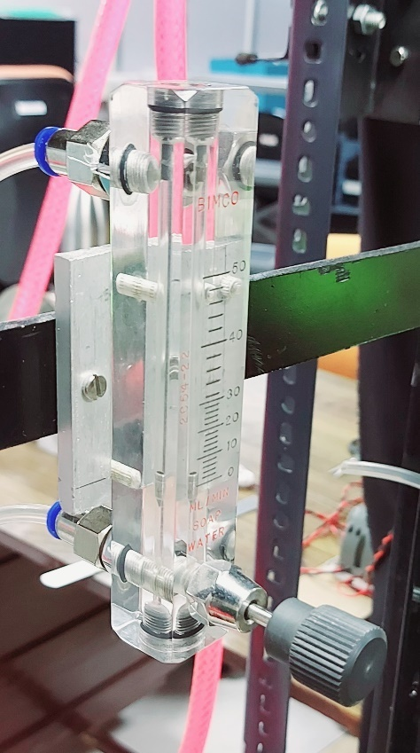

(b) (c)

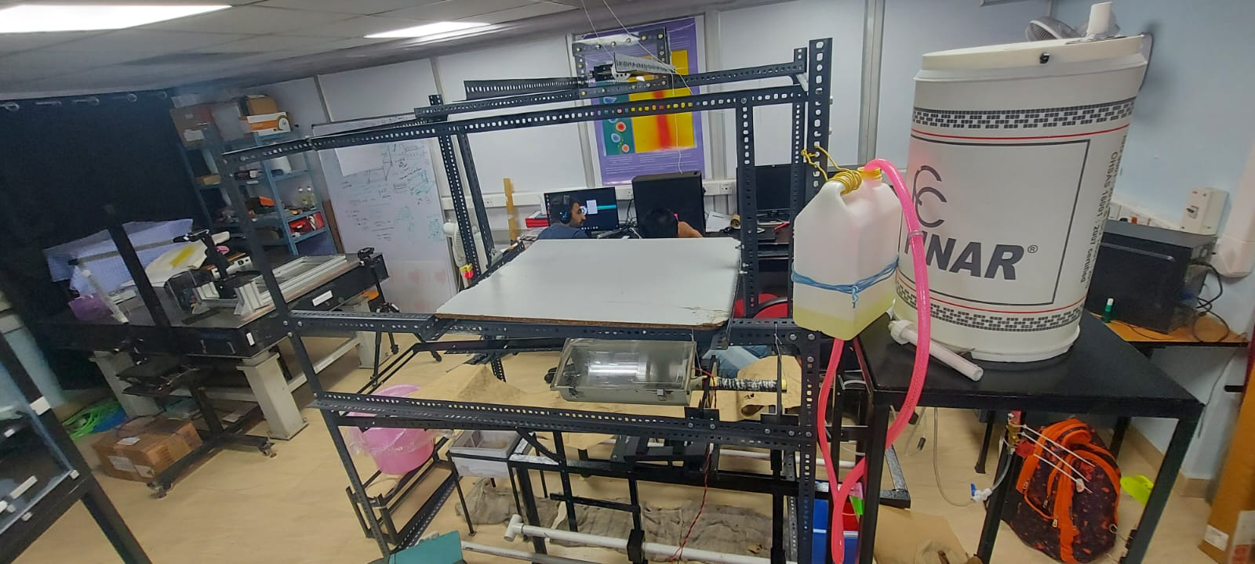

(d)

Fig.1 (a) *Schematic diagram of soap film,* (b) *Rotameter,* (c) *Top Reservoir,* (d) *The soap film tunnel experimental setup*

1. **V****ISUALISATION**

The flow structures formed behind bluff bodies in liquid soap film can be visualized through light interference effects produced by small variations in the film thickness. Such variations are generated during pulling of film from the reservoir due to gravitational effects, further downstream by the disturbing foreign objects such as circular cylinders, square cylinders, and diamond configuration of four flexible filaments.

The soap ﬁlm in conjunction with the use of a high-

speed pco.1200 hs camera operated at a frame rate of 800 fps,

as well as a low-pressure sodium lamp, produced images that

highlight the interference patterns of the soap ﬁlm, and illus-

trates how the wakes evolve within the ﬂow

The soap ﬁlm in conjunction with the use of a high-

speed pco.1200 hs camera operated at a frame rate of 800 fps,

as well as a low-pressure sodium lamp, produced images that

highlight the interference patterns of the soap ﬁlm, and illus-

trates how the wakes evolve within the ﬂow

The soap film in conjunction with the use of SONY digital still camera (DSC-RX10Miv) operated at a frame rate of 1000 fps as well as low-pressure sodium lamp, produced images that highlight the interference patterns of the soap film, and illustrates how the wakes evolve within the flow. The photographs illustrated below display the two-dimensional wake flow structure behind various objects from simple to complex geometries and arrangements. The wake generated from the interaction between the objects and the flow with different flow rates creates a number of artistic vortex patterns.

1. **von-Karman vortex generation due to circular cylinder**

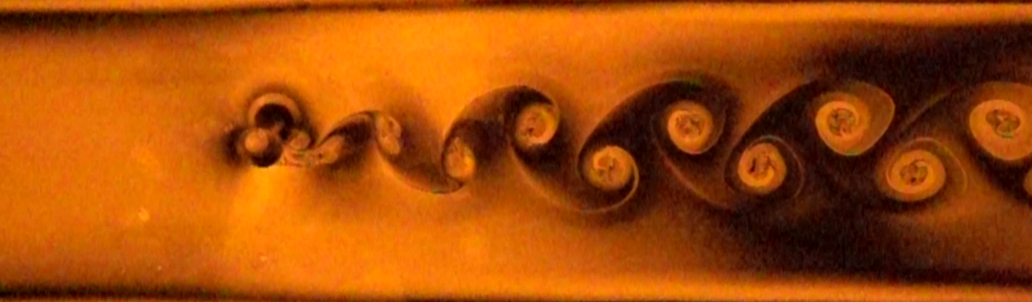

Fig. 2: *Visualisation of von-Karman vortex street behind a circular cylinder*

Formation of Kármán vortex streets by circular cylinders is studied in our experiment of flowing soap film. In fluid dynamics, a Kármán vortex street is a repeating pattern of swirling vortices, caused by a process known as vortex shedding, which is responsible for the unsteady separation of flow of a fluid around bluff bodies. The two-dimensional fluid flow in the film allows stable vortex streets to be generated. The current study focuses on the universal feature of the near-wake structures generated by circular cylinders in a uniform two-dimensional (2D) flow. A circular cylinder with diameter D = 6 mm was mounted perpendicular to the plane of the test section of the soap film and oscillated transverse to the flow direction.

Fig. 2 is a snapshot of a Kármán vortex street generated by the above-mentioned apparatus/setup. It was noticed that near the cylinder, the incipient vortex is very small, and it is not circular. However, the vortex grows rapidly in size and becomes circular in about two shedding periods. Inside the vortex there are many small-scale structures consisting of complicated folds and striations. Using fast video images, one observed that the eyes of the vortices rotate uniformly suggesting a nearly uniform distribution of vorticity.

1. **Vortex generation due to square cylinder with an attached filament**

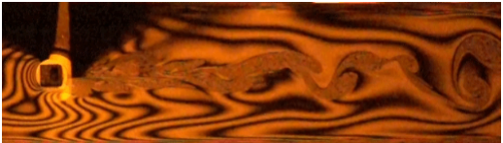

(a)

(b)

Fig. 3 (a)*Visualisation of vortices generated due to square cylinder with filament (a human hair)* (b)*Visualisation of vortices generated due to square cylinder with filament (a thread)*

In this experiment, square cylinder was taken having 10mm x 10mm dimensions and attached a filament (a human hair or a thread) at the tip of square cylinder such that filament should lie in the plane of film. The objective was to see the vortex induced vibration of the filament. It is observed that for a flexible filament with one end fixed in a flowing soap film, the flapping (or fluttering) of filament occurs only when the flow velocity exceeds a threshold value, which is called critical velocity. For a given length of filament, fluttering of filament is slow at low flow rates. Fluttering increases with high increase in flow rate. In Fig. 3(a), fluttering of human hair is very slow even at high flow rates and In Fig. 3(b), fluttering of thread is moderate at moderate flow rate. Hence, fluttering of filament could be due to the bending stiffness of the filament material. The human hair could be more stiffer compared to the Thread. Filament also delays the shedding generated by a square cylinder.

1. **Vortex generation due to diamond configuration of four filaments attached with cylinders**

Fig. 4: *Visualisation of vortices generated due to four filaments attached in a diamond configuration clamped at their leading edges (School of Fish in diamond configuration)*

In this experiment, Filaments (human hair) were attached with the tip of four cylindrical pen refill in a diamond configuration. It is observed that Vortex generated due to trailing filament of diamond collides with leading filament of diamond. After collision, vortices generated by both filaments merge with each other. From Fig. 4 , It can be observed that the trailing filaments exploit the vortices shed from the leader filament to generate their thrust.

1. **Vortex Detection (Using Image Processing)**

Now, The main objective was to find the shedding frequency of vortices. To detect the vortices, Image Processing was used. OpenCV-Python has found its use in various fields during the course of its development, especially in the shape and color detection of an actual image. Using contour detection, we can detect the borders of objects, and localize them easily in an image. It is often the first step for many interesting applications, such as image-foreground extraction, simple-image segmentation, detection and recognition.

When we join all the points on the boundary of an object, we get a contour. Typically, a specific contour refers to boundary pixels that have the same color and intensity. OpenCV makes it really easy to find and draw contours in images.

Initially, the images of flow behind a cylinder were taken in a flowing soap film tunnel and used following steps for detecting and drawing Contours in OpenCV:

1. **Read the Image and convert it to Grayscale Format**

Read the image and convert the image to grayscale format. Converting the image to a single channel grayscale image is important for thresholding, which in turn is necessary for the contour detection algorithm to work properly.

1. **Apply Binary Thresholding**

While finding contours, first always apply binary thresholding. This converts the image to black and white, highlighting the objects-of-interest to make things easy for the contour-detection algorithm. Thresholding turns the border of the object in the image completely white, with all pixels having the same intensity. The algorithm can now detect the borders of the objects from these white pixels.

1. **Find the Contours**

Use the findContours() function to detect the contours in the image.

1. **Draw Contours on the Original RGB Image.**

Once contours have been identified, use the drawContours() function to overlay the contours on the original RGB image.

To characterize the flow, Reynolds number is required. From OpenCV, the vortex shedding frequency can be detected. The vortex shedding frequency (𝑓) can be described reasonably by the classical Strouhal-Reynolds number relation St=a(1-b/Re) as shown in Fig. 5(a), where, Strouhal number *St = fD/U∞* , a=0.195, b=16.3 and Reynolds number *Re=U∞D/𝜈* . Using the empirical relationship between the Reynolds and Strouhal numbers obtained for cylinder wakes, effective soap-film viscosity and its dependence on film thickness can be estimated. Hence, for finding Reynolds number, vortex shedding frequency is to be measured.

(a)

(b)

Fig. 5. (a)*Strouhal number—Reynolds number relation for various circular cylinder wakes in the LFT,* (b) *Vortex Contour Image*

Finally, Fig. 5(b) was the result after following above steps. It shows original and denoised contour of vortices that can help in finding the Centre of vortices.

1. **CONCLUSION**

In conclusion, Soap film tunnels act remarkably like wind tunnels, using a two-dimensional fluid film instead of three-dimensional wind. The results show that the von-Karman vortex street can be visualised behind the wake of a circular cylinder in a flowing soap film at various flow rates. It could be observed that Vortex shedding frequency gradually begins with an increase in flow rates.

Visualization of flow patterns past various objects were observed in two-dimensional flow using soap film tunnel. It could be observed that while visualizing the wake behind a square cylinder with an attached filament, for a flexible filament with one end fixed in a flowing soap film, the flapping occurs only when the flow velocity exceeds a threshold value, which is called critical velocity. It could also be noted that for a given length of filament, fluttering of hair is slow at high flow rates while fluttering of thread is moderate at moderate flow rate. So, fluttering of filament depends on the stiffness of filament as well.

Visualisation of fish schooling was done by attaching four flexible filaments at leading edge in a diamond configuration. After acquiring high frame rate video of flow structure in this configuration, it could be observed that trailing filament exploit the vortices shed from the leader filament to generate their thrust.

Thus, flowing soap films provide us with a rich ‘two-dimensional laboratory’ for hydrodynamics experiments with minimally invasive, particle-free flow visualization.

**7. REFERENCES**

**[1]** Beizaie, M. and Gharib, M.

**Fundamentals of a Liquid (Soap) Film Tunnel, Experiments in Fluids, 23 (1997), 130–140**

<https://doi.org/10.1007/s003480050094>

**[2]** T. A. Shedd and T. A. Newell

**Automated optical liquid film thickness measurement method**

Review of Scientific Instruments 69, 4205 (1998); <https://doi.org/10.1063/1.1149232>

**[3]** Gharib, M., Beizaie, M.

**Visualization of two-dimensional flows by a Liquid (Soap) Film Tunnel. J Vis 2, 119–126 (1999).** <https://doi.org/10.1007/BF03181514>

**[4]** X. L. Wu, R. Levine, M. Rutgers, et al.

**Infrared technique for measuring thickness of a flowing soap film**

Review of Scientific Instruments 72, 2467 (2001); <https://doi.org/10.1063/1.1366634>

**[5]** Y. D. Afanasyev, G. T. Andrews and C. G. Deacon

**Measuring soap bubble thickness with color matching**

American Journal of Physics 79, 1079 (2011); <https://doi.org/10.1119/1.3596431>

**[6]** Sanghyeon Gil, Yoonji Seok, Kiyeol Park, Jaeseok Yoo and Seongah Chin’

**Soap film flow and thickness for soap bubble rendering**

In Proceedings of VRST '19: 25th ACM Symposium on Virtual Reality Software and Technology (VRST '19), November 12-15, 2019, Parramatta, NSW, Australia. ACM, New York, NY, USA, 3 pages.

<https://doi.org/10.1145/3359996.3364716>

**[7]** Leslie J. Atkins

**Thin‐film interference using a computer's screen and camera**

The Physics Teacher 49, 62 (2011); <https://doi.org/10.1119/1.3527766>

**[8]** M. Gharib and P. Derango

**Flow Studies of a Two-Dimensional Liquid Film Jet**

The Physics of Fluids 31, 2389 (1988); <https://doi.org/10.1063/1.4738824>

**[9]** Morteza Gharib, Philip Derango

**A liquid film (soap film) tunnel to study two-dimensional laminar and turbulent shear flows**

<https://doi.org/10.1016/0167-2789(89)90145-0>